**Parts of a wind turbine**

* 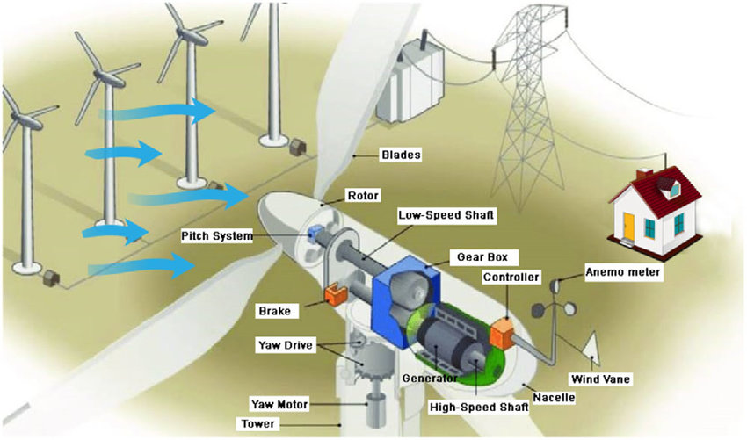**Blades:** Capture the wind's energy and convert it into rotational motion. They are aerodynamically designed to maximize efficiency and minimize drag.
* **Rotor:** The assembly of blades and hub that rotates to capture wind energy. The hub connects the blades to the low-speed shaft.
* **Low-Speed Shaft:** Transmits rotational motion from the rotor to the gearbox. It is a large, sturdy shaft that can withstand the forces generated by the wind.
* **Pitch System:** Controls the angle of the blades to optimize energy capture and protect the turbine. By adjusting the pitch, the turbine can regulate its power output and reduce stress on the components.
* **Gearbox:** Increases the rotational speed of the low-speed shaft to match the generator's optimal speed. This is typically done through a series of gears that multiply the rotational speed.
* **Generator:** Converts rotational motion into electricity. The generator is a large, powerful machine that produces electricity based on electromagnetic principles.
* **High-Speed Shaft:** Transmits rotational motion from the gearbox to the generator. It is a smaller, higher-speed shaft that connects the gearbox to the generator.
* **Nacelle:** The housing that contains the generator, gearbox, and other components. It is a large, aerodynamic structure that protects the internal components from the elements.
* **Yaw Drive:** Allows the turbine to turn to face the wind for maximum energy capture. It is a mechanical system that enables the turbine to rotate around its vertical axis.
* **Yaw Motor:** Powers the yaw drive. It is an electric motor that provides the necessary torque to turn the turbine.
* **Tower:** Supports the nacelle and rotor, raising them to areas with higher wind speeds. Towers are typically made of steel or concrete and are designed to withstand the forces of wind and weight.
* **Anemometer:** Measures wind speed to control the turbine's operation. It is a sensor that measures the speed of the wind at different heights.
* **Wind Vane:** Determines wind direction for proper turbine orientation. It is a weather vane that indicates the direction of the wind.
* **Brake:** Stops the turbine in case of emergency or maintenance. It is a mechanical system that can quickly bring the turbine to a stop.
* **Controller:** Monitors and controls the turbine's operation, ensuring optimal efficiency and safety. It is a computer system that collects data from various sensors and makes decisions about the turbine's operation.